The chart below shows how much money is spent in the budget on different sectors by the UAE government in 2000.

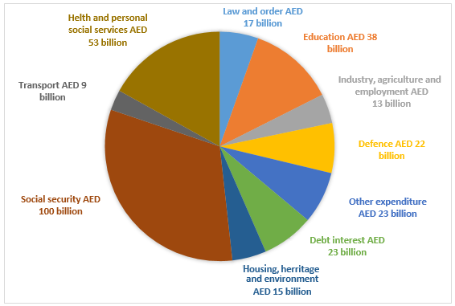

The chart provides information about costs of government in United Arab Emirates in 2000. Generally speaking, they spent over 300 billion on different sectors in this year and the highest proportion of expenditure went on social security.

A more detailed look at the bar chart reveals 100 billion AED as the highest expenses, while transport costs were only 9 billion AED. It is the lowest budget price in this year. Health and personal social services, which is have an important meaning for population in UAE and have a place to be on the second position of government costs — 53 billion AED were spent for this. Followed by the previous sector in top of costs is Education for marvelous and wide-open minds. It demanded 38 billion AED. This sector also even higher than budget for defence, other expenditure, debt interest and housing, heritage and environment, which all required around 20 billion AED. And the last one is low and order, industry, housing and heritage sectors. They summed up at 45 billion.

Clearly, the government of the UAE spent plenty of money on social security and the lowest expenditure has a sector of transport.